**SECURITY CONCEPT IN ORACLE FUSION**

**INTRODUCTION:**

Fussion Applications Security is designed based on Role-Based Access Control (RBAC). It is an approach to restricting access to authorized users.

**THREE TYPES:**

WHO: User(Job)

WHAT:Type of action user can perform.

WHICH:Which data that can access.

**TYPES OF ROLES:**

1. Job Role
2. Abstract Role
3. Duty Role
4. Data Role

Job Role:

Job roles provide user with permission that they need to perform activities specific to their jobs.

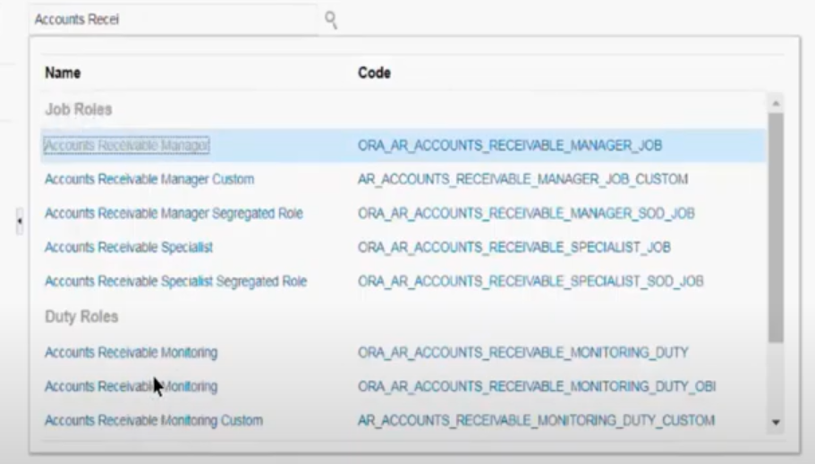

EX:These are the job roles comes under accounts receivables.

**Abstract Role:**

That users require to perform the tasks associated with the duties of work not specific to a particular job.

**Duty Role:**

Grouping of privileges that represent individual duties that users perform as part of their job.

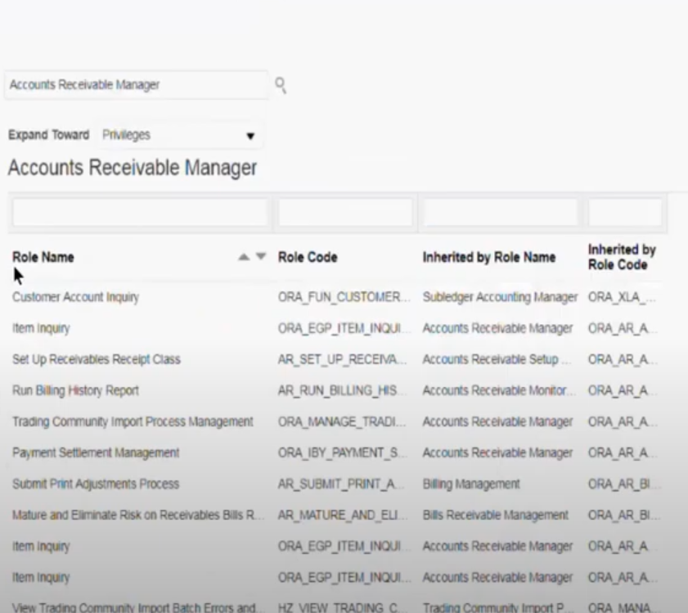

Ex:These are the role name(Duty Role)comes under Accounts Receivable Manager.

Data Role:

Which data want to access.(navigation setup and maintenance)

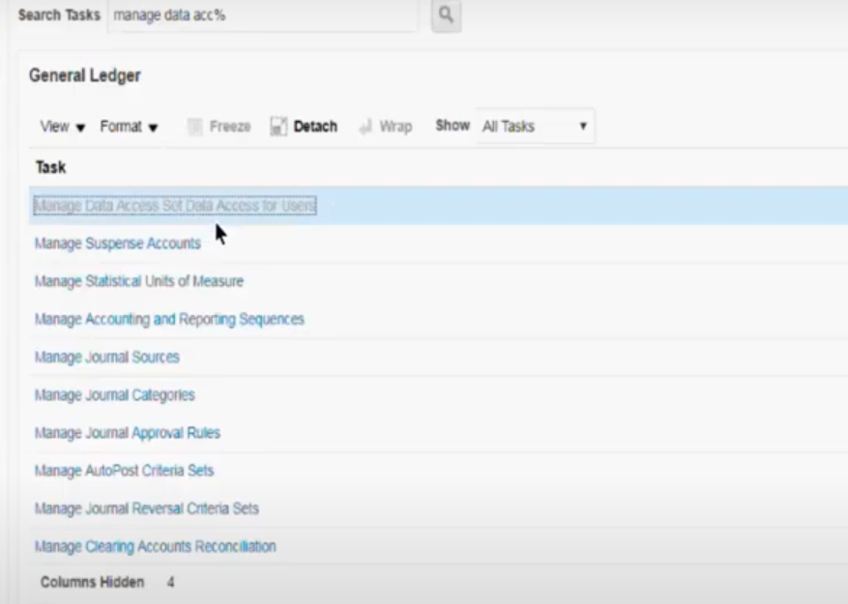

Ex:User can access only to that particular task.